A-Team Tutorials

1.3 Identify and Measure

Astrometrica
At Level 1 you will learn how to measure the astrometric position (coordinates) and photometric brightness (magnitude) of an object using FITS images downloaded from a Slooh mission. The initial challenge is to install Astrometrica and develop some skill at using it. The program has built-in help and tutorials, so I am not going to repeat the fundamentals here.
Astrometrica will be used to:
- Open the FITS files and display the images.
- Perform “Data Reduction” to download part of a star catalogue for that area of sky and match the stars in the catalogue to those in the image.
- Show “known objects” where asteroids and comets with known orbits are indicated in the image.
- “Blink” the images so that we can clearly identify movement of the target.
- Measure the position and magnitude of the target.

Installation
Astrometrica is a major piece of software, and you will need to be prepared to spend some time learning how to use it. It is also not free – but you get 100 days to play before you pay and at €25 it is well worth it!
The home page of Astrometrica has some introductory information and links to a download page. Download the full installation package, “Current Version with ADES format output”, including tutorials and follow normal instructions to install it. You do not need to download a star catalogue as we will access the main catalogues online. Have a look through the Help topics and get an idea of what all the menu items are about. Do at least Tutorial I. There are lots of discussions about Astrometrica on the web and you may like to watch a tutorial on YouTube.
Before attempting to go any further with images from Slooh telescopes you will need to get some configuration files for the Slooh telescopes.
Firstly, open Astrometrica and go to Settings/Environment tab. There you will see three directories named. Make a note of the one called MPCOrb. This is where your Astrometrica has decided to keep its copy of MPCORB.DAT (the orbits database).

Settings and Configuration Files
Astrometrica needs to be specifically configured for the telescope and camera system being used. The Files/Settings menu item leads to a set of tabs containing information about you, the telescope, camera, filter, star catalogue and other options. Settings are saved in configuration files. You will eventually accumulate lots of configuration files for the various telescopes and types of images. So, set up a folder to hold them.
As the configuration settings vary from time to time, you should get an initial set of current files from your A-Team tutor and tailor them for yourself.

Tailor configuration files
The configuration files will arrive in an email. Set up a suitably named folder for them and save them.
Start Astrometrica and select File/Settings/Open and select one of the supplied configuration files.
Go to the Observing Site tab and replace the name with your own name.
- The format of the name is important. Observations submitted to the Minor Planet Centre will eventually be published in official scientific documents and your name will be indexed in the NASA Astrophysics Data System (http://cdsads.u-strasbg.fr/) (ADS).
- The format must be first initial, full-stop, blank, (second initial, full stop, blank), surname.
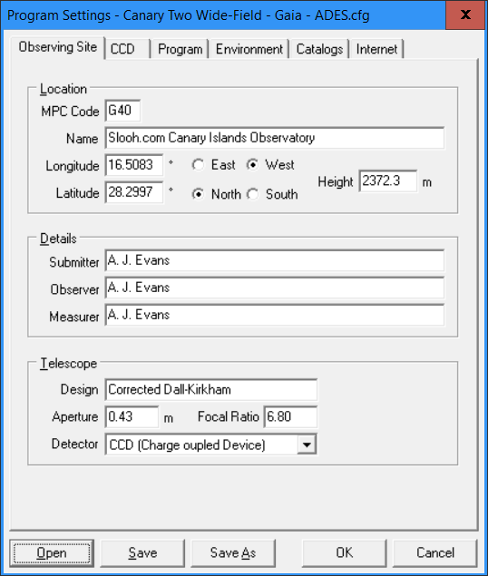
Observing Site Tab

Go to the Environment tab and change the directories to those in your installation. You set each directory by selecting the […] browse button and navigating to the required folder.
- CCD Images: Set the folder you want Astrometrica to open when you select File/Load images.
- MPCOrb: select the folder in which Astrometrica keeps its copy of MPCORB.DAT. Hopefully, you will have made a note of this earlier but if not, it can usually be found at C:/Users/(username)/AppData/Astrometrica.
- Output: This is where Astrometrica puts its output reports. The default is usually OK.
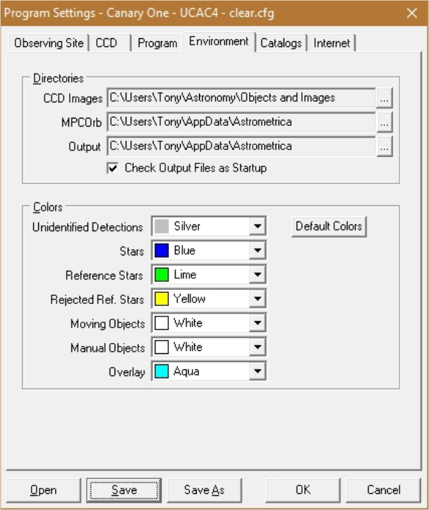
Environment Tab
You can now “Save-as” the modified configuration file, giving it your own name and folder location.
Repeat the same process for each of the configuration files supplied by your tutor.

MPCOrb
MPCOrb is a file containing information about the orbits of all known asteroids. Astrometrica uses the information in this file to work out where to put “known object” boxes in images. It is necessary periodically to download a new copy of MPCOrb to ensure you have current information about recently discovered objects. This can be achieved in Astrometrica using Internet/Download MPCOrb. If you have not done that recently, do it now.
Now you are ready to process Slooh images.

Data Reduction
The objective of Data Reduction is for Astrometrica to match the pattern of the stars in your image to a star catalogue that contains precise details of their position and magnitude. Having done that, Astrometrica works out some figures that allow it to calculate the coordinates of each pixel in the image and to estimate the magnitude of any group of bright pixels.
Open Astrometrica and check that you have the right configuration file loaded for the telescope and filter used for the image. (Configuration file-name is shown bottom right).
File/Load one of the FITS images from your first mission.
If Astrometrica shows you the FITS date/time stamp do not change it, just press OK. The time stamp in the FITS header is accurate to about 1 second but the time in the file name is only approximate. (You can switch off seeing the time stamp in File/Settings/CCD/Skip checking of Time after Loading.)
Select Astrometry/Data Reduction. Astrometrica needs to know the approximate coordinates of the centre of the image. You should enter the RA and Dec from the file name of the image and press OK. This is always the best way to set the coordinates and works regardless of whether your target is near the centre of the image or not.
- (Remember to select South if the Decl is negative).
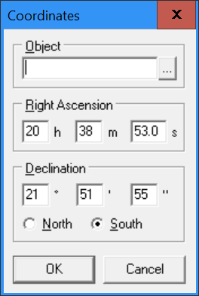
Set coordinates from the file name.
Select OK and Astrometrica will download part of a star catalogue and try to match the stars in the catalogue to the image. If it is successful, you will see a Data Reduction Results window containing information about what was found.

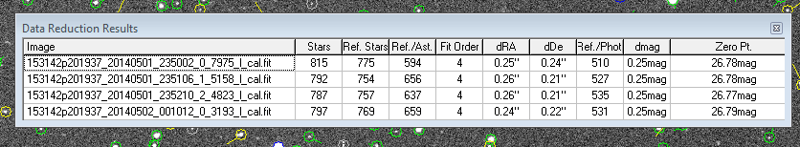
Data Reduction Results
At this stage you should only be concerned that there at least a few tens of Ref.Stars and that Fit Order is not red!

Data Reduction problem?
If there is a problem with Data Reduction you will see a message like this:
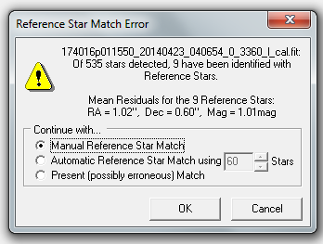
Data Reduction Error
Select OK and you will see another dialog like this:
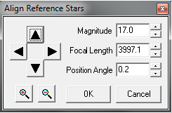
Adjust for a star match.
Use the arrows to shift the circles around until they fit over the stars. You can try using the other adjustments as well to see what the effect is. When all the circles and stars are well aligned, press OK and you should see the expected data reduction results.
If you cannot get a match, check you really have the correct configuration file loaded. Start again and repeat the procedure. If still no success, ask for help!

Complete data reduction
Assuming you have completed data reduction for the first image, File/Load one image from each of the other missions (leaving the original one open in Astrometrica). Repeat Data Reduction for these images.
Notes:
- You can load multiple images and try to do Data Reduction on them at the same time. This may work but it depends how consistent the telescope pointing was from image to image.
- If you try to do Data Reduction with the wrong configuration file loaded, it won’t work! If you then load a different configuration file and try Data Reduction again it probably will still not work! You need to close Astrometrica and start again!
- If you used the Multi 50s recipe for your missions, you will have several luminance images for each mission. It does not matter which one you use for this exercise, but you only need one from each mission.
- If you cannot make it work, ask for help.

Identify
With Data reduction completed for all three images, select Tools/Known Object Overlay. Astrometrica will search the database (MPCOrb) and work out which objects should be showing in your images. It will draw a little box round them. You can use zoom to inspect closely.
Known Objects
In my example, the green circles are stars used as references and white boxes are known objects. You can select Image/Select Markings to change what is shown and Settings/Environment to change the colours used.
You should see your target object marked somewhere near the middle of the image.
There may be other known objects in the image and, depending on their magnitude, they may be visible. (You can measure them too if you like).
The “known object” box is sometimes not very well positioned relative to the object in the image. Do not worry too much about that. The main thing is to identify your object by seeing it move when “blinking”.

Blinking
Select Tools/Blink. This will create a new window with the three images “blinking” and clearly showing movement. You can create an animation using any screen capture software you may have. (I find Screen-to-gif convenient for this). Post the results in the Slooh Workspace if you like. (You will see lots of examples in the A-Team and Comets Workspaces).

Measure
The last stage of the process is to measure the position and magnitude of your target. Having carefully located its position (use the magnify window if it helps) click on it and the Object Verification window will open. Click on the […] button next to Object Designation and a list of likely objects will appear. Select the correct one and OK.
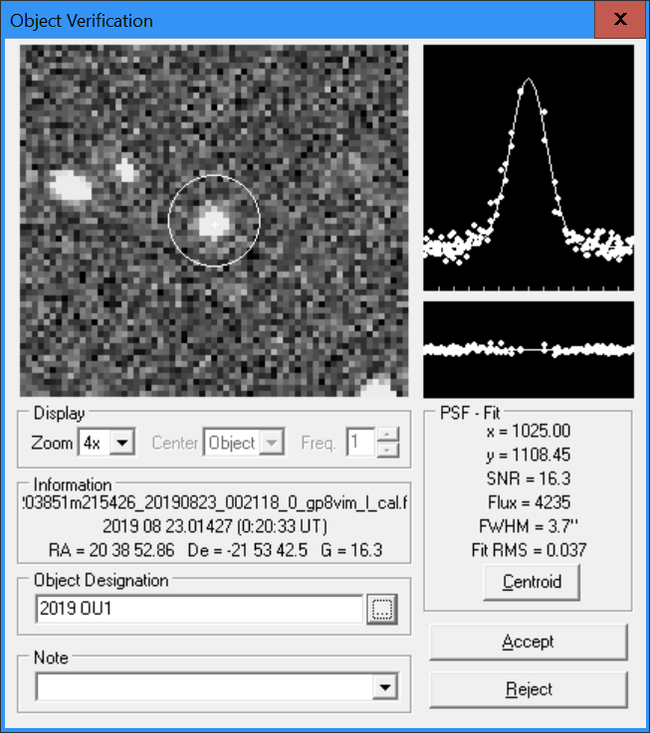
Object Verification
Repeat the measurement for all three images, then select File/View ADES Report File. You will see something like this:
ADES Report
What this all means is beyond the scope of level 1. Suffice to say that this file contains details of the measurements you have just made in the official Astrometry Data Exchange Standard (ADES) format.
First published April 2014. Last update 22 Mar. 2024.
Tony Evans

